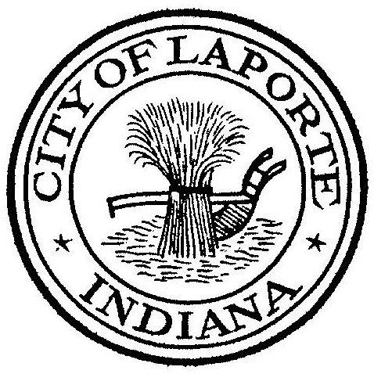
Board of Public Works and Safety
Jessica Romine, Member Tom Dermody, Mayor Mark Kosior, Member
City Hall 801 Michigan Ave., La Porte, IN 46350
Wednesday, November 9, 2022
9:00 AM
AGENDA
- Call To Order
- Pledge Of Allegiance
- Approval Of Minutes
- Public Comment: In Person and via Facebook Live
- Clerk-Treasurer: Claims Approval
-Approval of Third-Party Agreement for the Police Dept.
- New Business:
-Proposed 2023 Holiday Schedule
-Proposed 2023 Board of Works Meeting Schedule
-Request For Use: Tree Mann
Turkey Trot
-Andrea Smith: Job Description(s): Full-time Asst Dir Park & Rec
Part-Time Event Coordinator Civic Auditorium
Communications Director
-Jerry Jackson: Wastewater Basement Protection Grant Application
Phosphorus Pay Request #7
-David Heinold: Preliminary and Final Plat for Smoothie King Lot Resubdivision
-Beth West: Amended Operating Assistance Agreement for Grant #1 IN-2020-039
-Nick Minich: Recommend Award-Emergency Vehicle Preemption
Recommend Award-Ice Rink
Schneider Pay Application #3 -Civic Roof
8) Unfinished Business:
1)Toys for Tots collection has begun, you can drop off new unwrapped toys at City Hall
2) This Thursday, November 10th we will kick off the Red Bucket Campaign at City Hall with a
Coffee Pour from 8am to 10am. Join the current and some former Mayors for a cup of coffee
and help the Salvation Army meet the need in our community.
3) The Veterans Day Ceremony is Friday, November 11th at the Civic Auditorium. There will be
coffee and Donuts in the lower level from 9a to 10a, the Ceremony will start at 10:30a and
there will be a spaghetti lunch at Noon at the VFW. The lunch is free to each Veteran and
1-guest.
9) Other Business: Next Meeting will be on Tuesday, November 22, 2022

